**Tarea 7 Calcular Matriz Homogenea del Robot de 3 GDL**

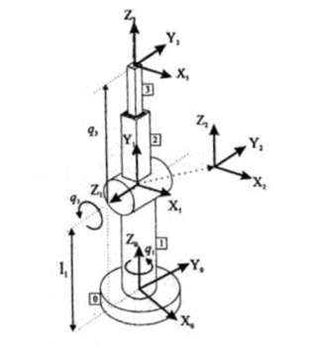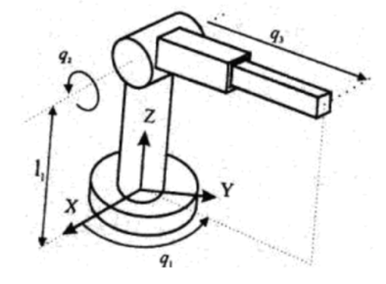

|  |  |  |  |  |
| --- | --- | --- | --- | --- |
| **Articulaciones** | $$θ_{1}$$ | $$d_{i}$$ | $$a_{1}$$ | $$∝_{i}$$ |
| **1** | $$q_{1}$$ | $$L_{1}$$ | $$θ$$ | **-90º** |
| **2** | $$q_{2}$$ | **0** | $$θ$$ | **90º** |
| **3** |  |  |  |  |

|  |  |  |  |
| --- | --- | --- | --- |
| **Cq1** | **-Sq1** | $$θ$$ | $$θ$$ |
| $$θ$$ | $$θ$$ | **1** | $$-L_{1}$$ |
| **-Sq1** | **Cq1** | $$θ$$ | $$θ$$ |
| $$θ$$ | $$θ$$ | $$θ$$ | **1** |

|  |  |  |  |
| --- | --- | --- | --- |
| **Cq2** | **-Sq2** | $$θ$$ | $$θ$$ |
| $$θ$$ | $$θ$$ | **-1** | $$θ$$ |
| **Sq2** | **Cq2** | $$θ$$ | $$θ$$ |
| $$θ$$ | $$θ$$ | $$θ$$ | **1** |

|  |  |  |  |
| --- | --- | --- | --- |
| **1** | $$θ$$ | $$θ$$ | $$θ$$ |
| $$θ$$ | **1** | $$θ$$ | $$θ$$ |
| $$θ$$ | $$θ$$ | **1** | $$q_{3}$$ |
| $$θ$$ | $$θ$$ | $$θ$$ | **1** |

|  |  |  |  |
| --- | --- | --- | --- |
| **C(q1)S(q3)** | **C(q3)S(q1)** | **-Sq2** |  |
| **-S(q1)** | **C(q1)** | $$θ$$ | $$θ$$ |
| **C(q1)S(q2)** | **S(q1)S(q2)** | **C(q2)** | **q3-L1C(q3)** |
| $$θ$$ | $$θ$$ | $$θ$$ | **1** |